Preparing Students for Workforce 2020
Activities to help teachers to ensure students have a positive experience as they prepare for the future
Table of Contents

What is Workforce 2020?
Workforce 2020 is set up in the same way that a career fair is set up. Hundreds of local employers will be set up in booths and will conduct mock interviews with your students. They will ask questions and they will be prepared to provide information about careers in their field and at their specific place of employment. Employers will provide a critique of your students’ resumes and interview skills.
Students will arrive by bus at the Workforce 2020 site at a predetermined time. Students will enter the location and will see that multiple other schools are present with large numbers of students. The activity, noise level, and volume of students might be overwhelming for some students.
How to Improve Your Students’ Experience
We recommend that you prepare your students for this experience by using role-playing, modeling, and even social stories if appropriate. It is okay to have your students complete mock interviews at your school with people they are not familiar with.
It might also be appropriate to develop a safety plan for your students and check in with them frequently. If the setting becomes overwhelming to your students, have a plan in place of how a student can be removed from the setting so they are able to calm themselves.
Some students thrive on knowing the schedule for the day. Feel free to share the day’s schedule, but prepare the students to be flexible, as some interviews may take longer than others.
Within this guide you will find some role-playing and social stories activities, along with other ideas to help students feel ready to participate in this wonderful experience.

Workforce 2020 Social Story

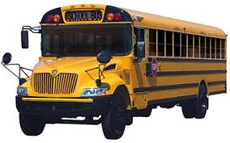

To attend Workforce 2020, you will ride a school bus to the Watertown Airport.

You will need to bring your folder that includes your resumes for your discussions and interviews with professionals.

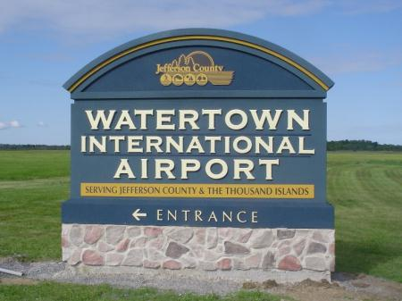
You will arrive at the Watertown International Airport.

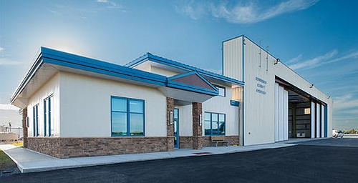
At the airport, you will be going
into the airport hangar; this is where
they normally keep the planes. No
planes will be in the building today.

The hangar is a room much like the
gym at your school.

When you enter the hangar, there will be a lot of people there. There will be students and adults.
The room will be filled with tables with different employers that are interested in hearing about you, asking you questions, and answering any questions you have. The room will have a lot of noise in it because a lot of people will be talking all at once.
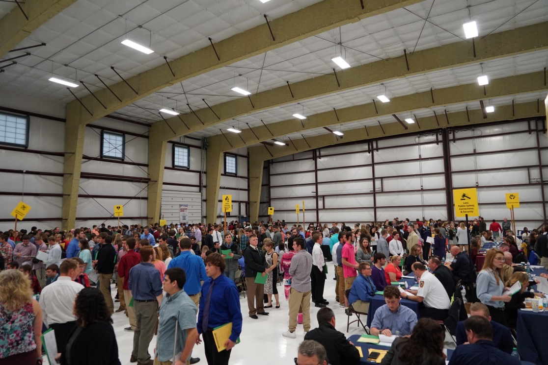
If you begin to feel uncomfortable, ask one of your chaperones to take you where it is quieter.

You will follow the signs and the directions of your chaperones on where to go once you’re in the hangar.

You will have your choice of what professions you go to. You will most likely be sitting next to other students and will be able to hear them talking.
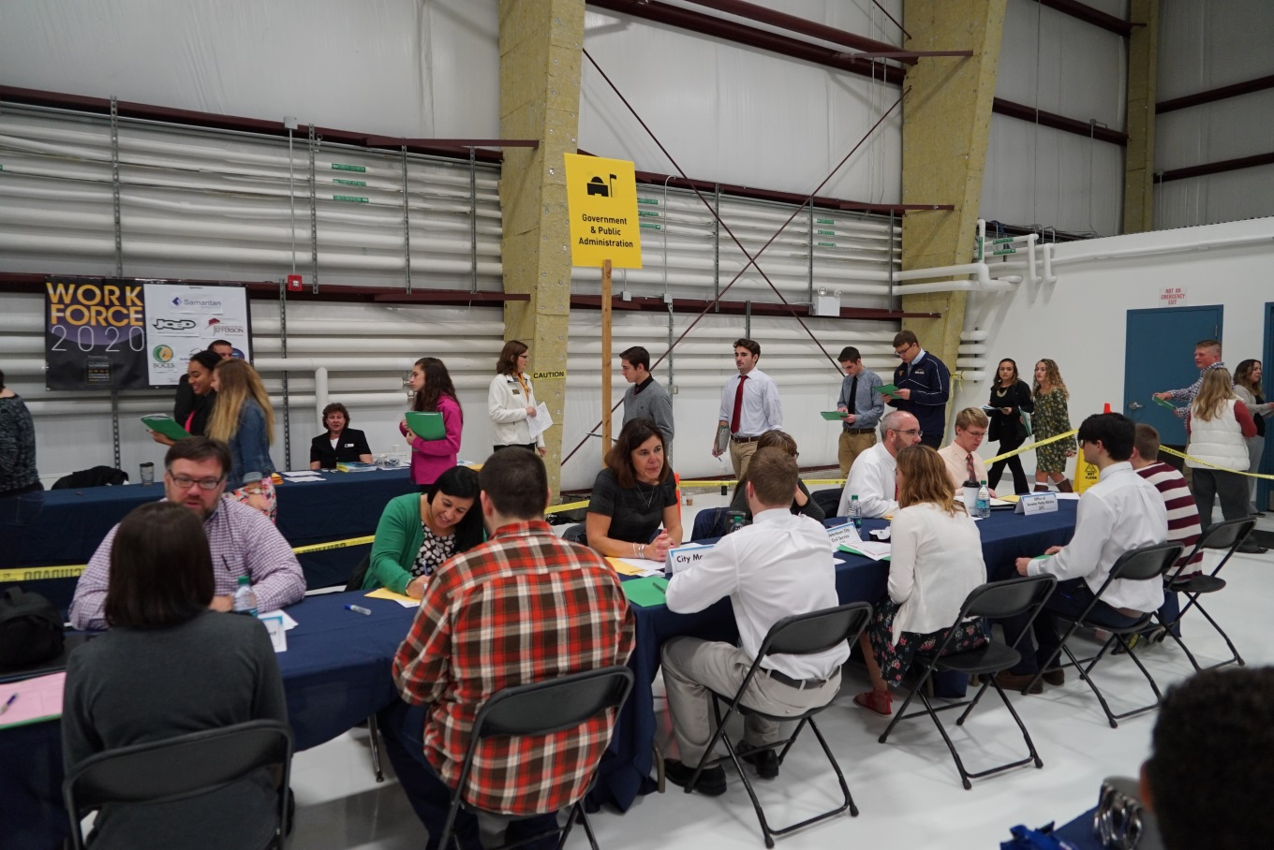

Try to focus your best on the person you are speaking with, and remember your interviewing skills!
They will announce when it is time for your school to finish up and leave.

Follow the signs and other students as they make their way to the exit.
You will exit the hangar and take the school bus back to your school.

What Are My Strengths and Weaknesses?
Adapted from http://www.going-to-college.org/myplace/activities.html#strengths
Background: Employers want to know what a person can bring to their organization. It is important for students to be able to identify their strengths and how those strengths can be an asset to the organization they are applying to.
- Using the strengths inventory at http://www.literacynet.org/mi/assessment/findyourstrengths.html, determine your strengths, print them out, and have a discussion with parents, classmates, teachers, etc. Do they agree or disagree with the results?

- The Career Key outlines 17 Foundation Skills that workers need to be successful in the workplace in the 21st Century. Using the attached handout, read, think about, and determine if you have these skills or if you need to improve upon these skills.

- Using student discussions and Foundation Skills article, determine strengths and weaknesses students sees within themselves. This can be done in a graphic organizer form. Encourage students to provide evidence and real life examples to support their thinking.

- Have students work to develop strength statements that could be used in an interview for a job in their chosen field. According to https://www.ldsjobs.org/ers/ct/articles/power-statements?lang=eng, “When presenting your skills to others, use concise statements that briefly describe the value you can bring to the organization.”

- Practice questions like the following to prepare students to promote their strengths to potential employers:
- What do you feel sets you apart from the competition?
- How would you apply your key strengths to this position?
- Why should we hire you?
- What makes you the ideal candidate for this job?
- What makes you a good fit for the position?

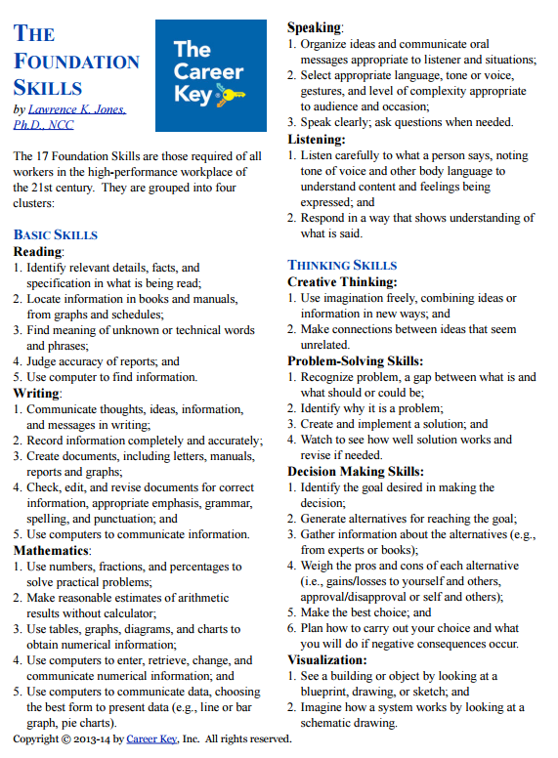
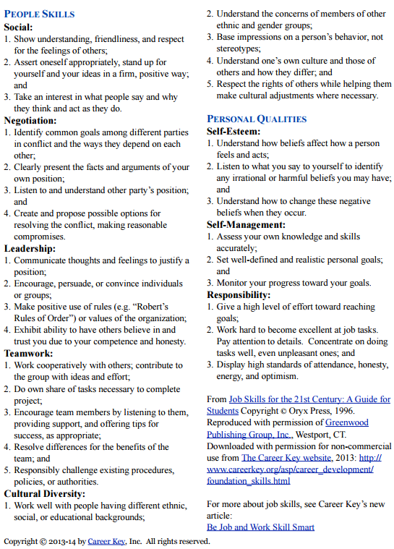
Name: ________________________
My Personal Strengths and Weaknesses

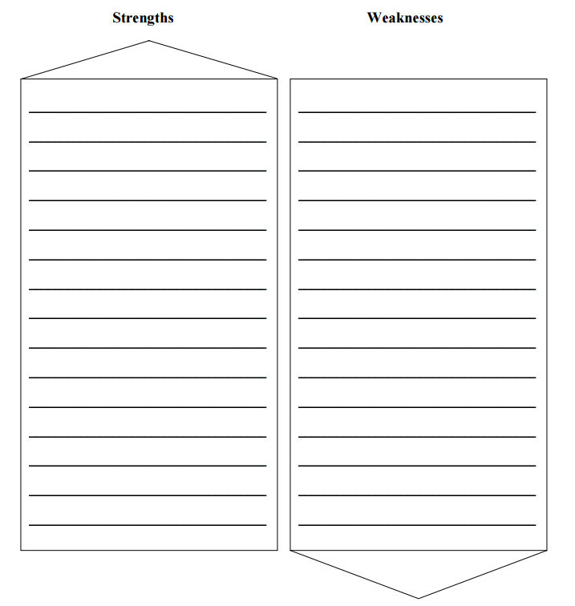
Identifying Occupations of Interest
Adapted from:
Job seeking skills for people with disabilities: a guide to success: student handbook. Northridge, CA:
California State U, Northridge, National Center on Deafness, Transition Resources and Career
Services for Students with Disabilities, 2001. Print.
Background: Many times students have their hearts set on one occupation. Unfortunately they do not have the requisite skills for the occupation. What they do not know is that they might still be able to work in the field. It is important that students explore all job possibilities within an occupation.
- Begin to determine which careers match your skills. Using the website http://www.educationplanner.org/students/career-planning/find-careers/careers.shtml, determine some careers that meet your skillset.

- Using www.mygpsforsuccess.com, use the attached Career Research Worksheet to explore careers of interest.

- Research skills needed for career choices. Careertech.org outlines the strengths needed for each of the 16 career clusters at https://www.careertech.org/career-clusters. Think back and analyze your strengths and weaknesses. Do they match the skills needed for your career choices?

Name: __________________________
Career Exploration Worksheet
Adapted from www.successtoolkit.org
Career Title:
Provide a brief description of the job. Include the nature of the work, environment, responsibilities, average work week, etc.
Describe key skills, abilities, and personality traits important for this career. | Skills and abilities:
 | Personality traits:
What is the average or median salary range for this career both national and locally? | National:
 | Local:
What is the outlook for the future of this career? Does research show growth or decline in hiring?
What is your overall impression of this occupation? | Pros:
 | Cons:
After learning more about this career, are you still interested? Would this career fit the lifestyle you want? Does it match your interests, personality, skills and work values? | - Still Interested  - Not Interested (skip question below)  This career is a good match for me because:
List two occupations that are similar that you may be interested in researching. | Similar careers:  1.  2.

Social Story – Going to a Job Interview
(http://weraspies.weebly.com/uploads/6/8/5/9/6859492/interview_social_story.pdf)
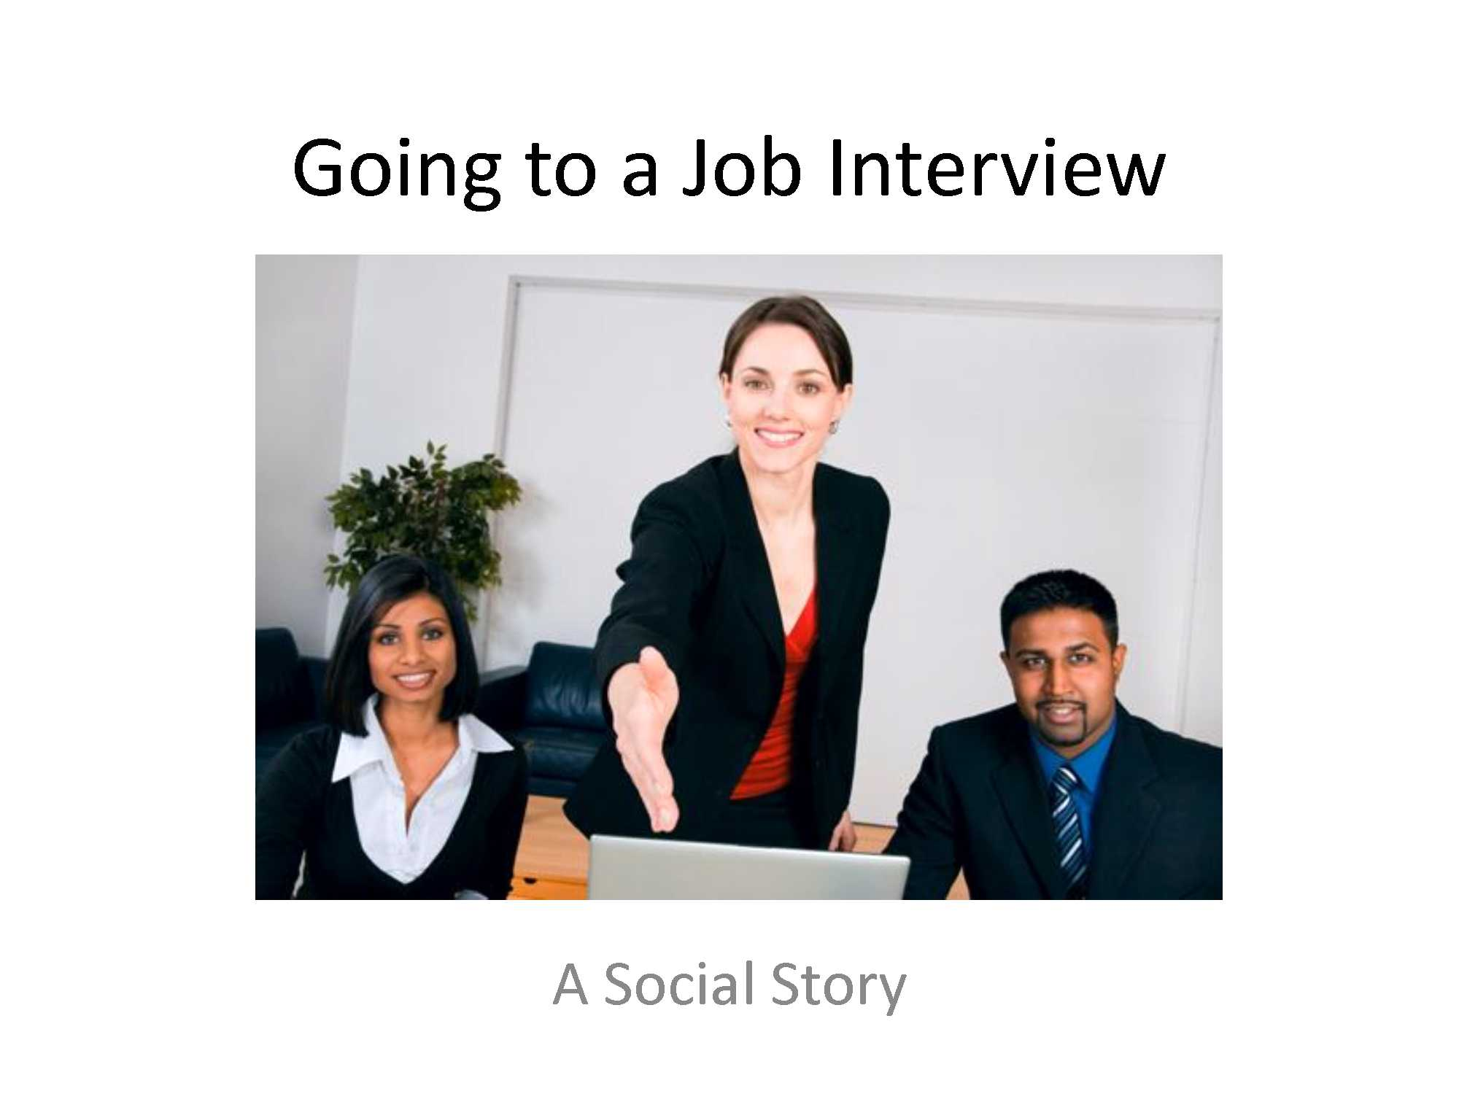
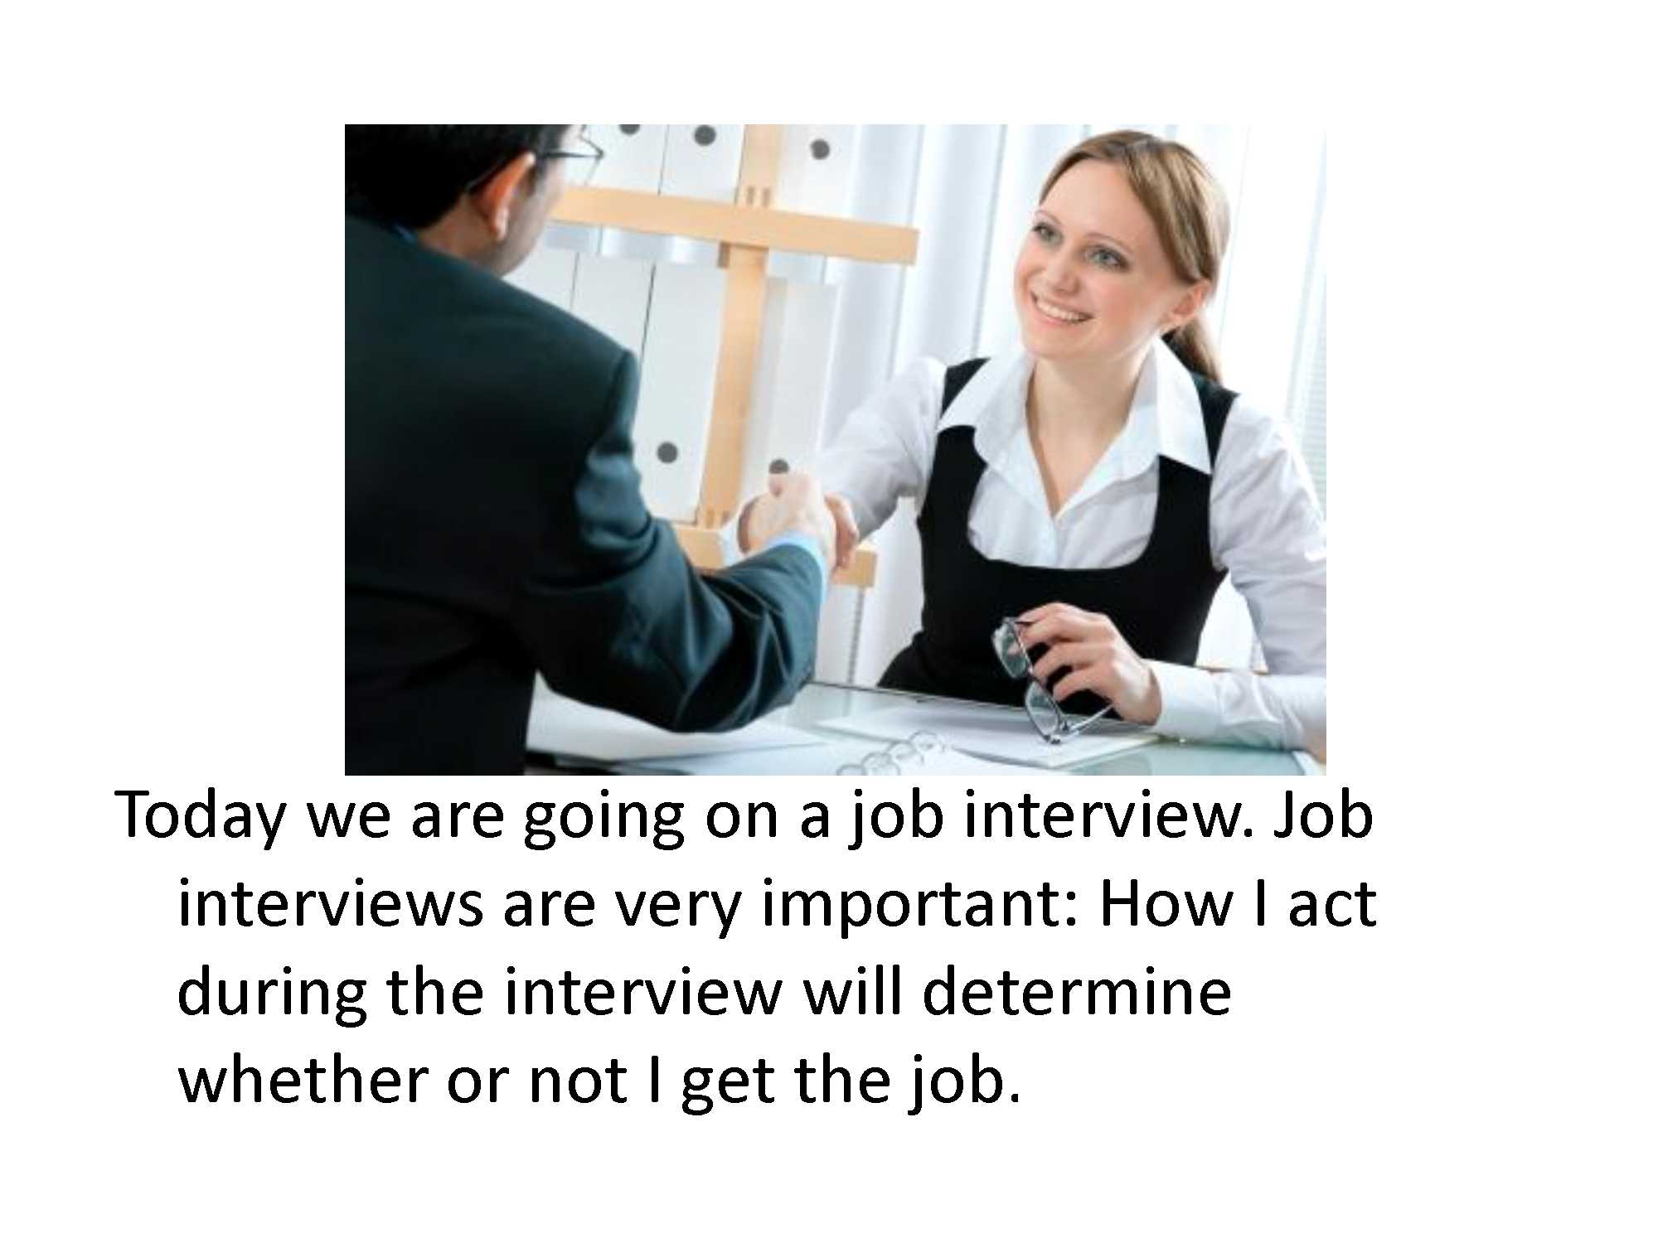
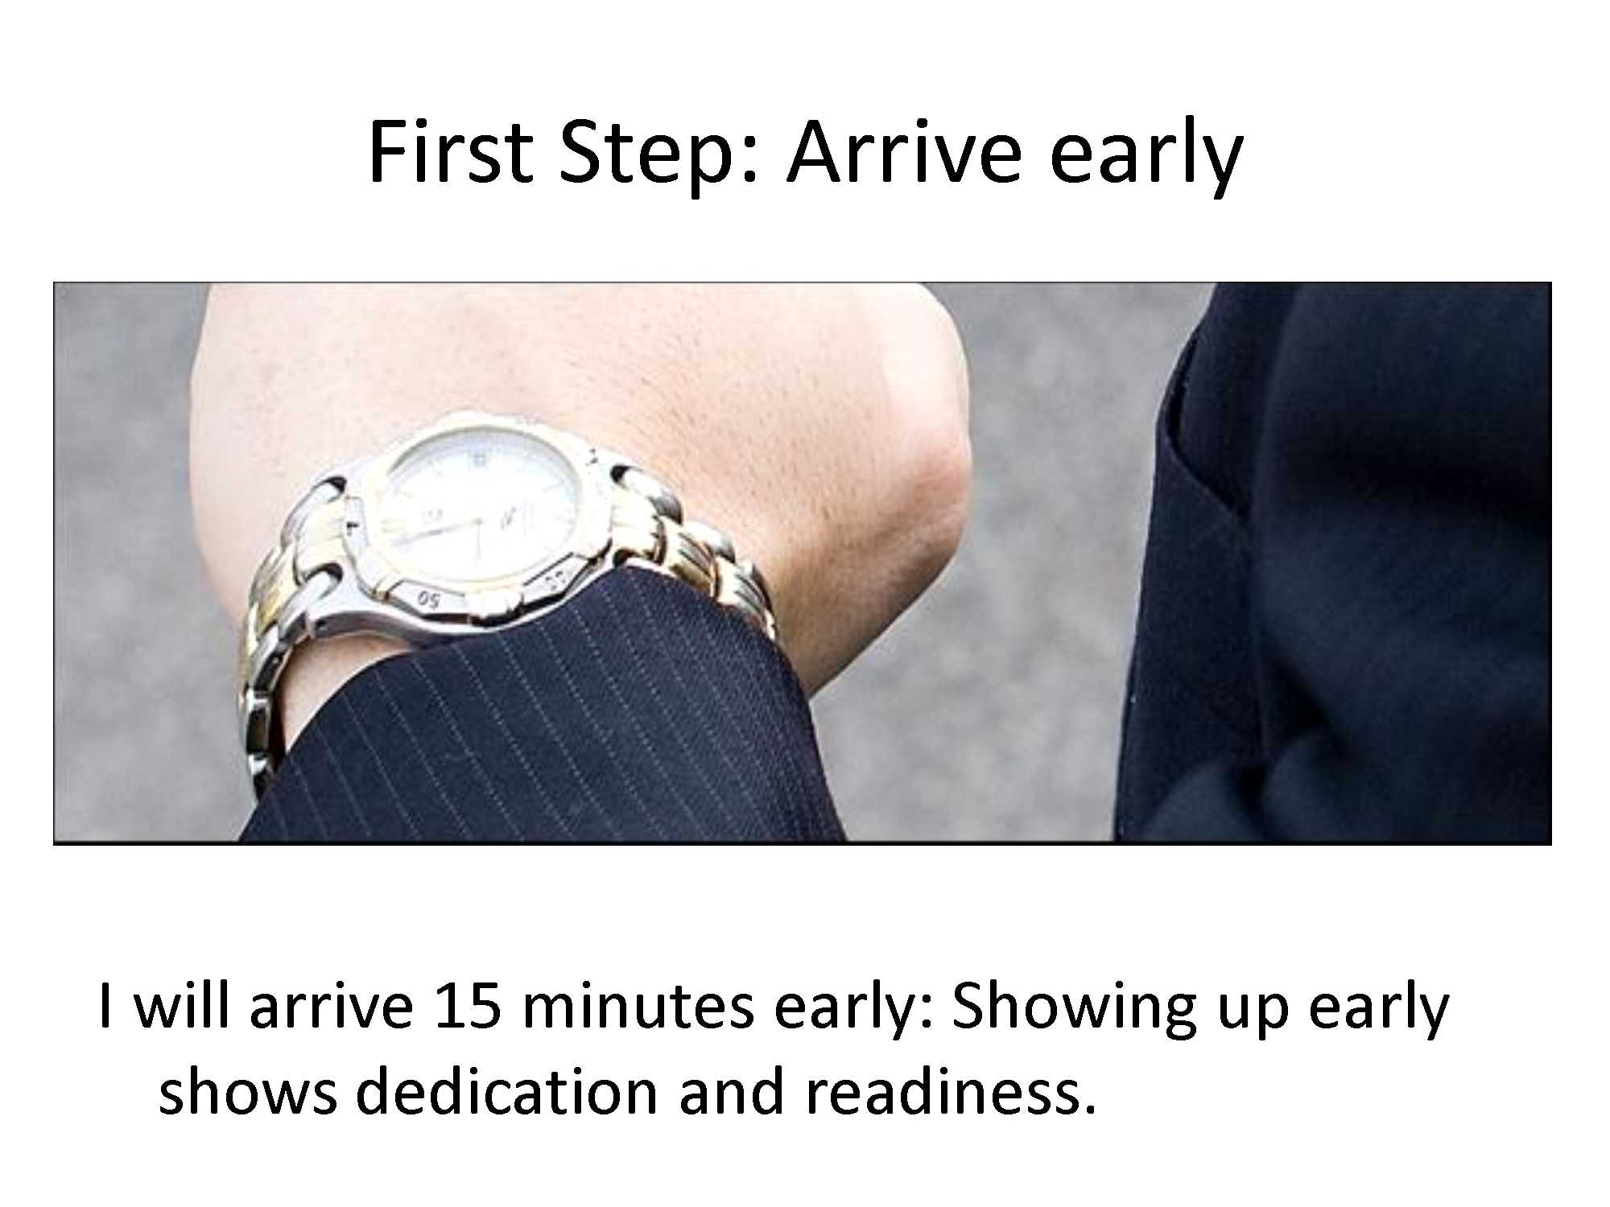
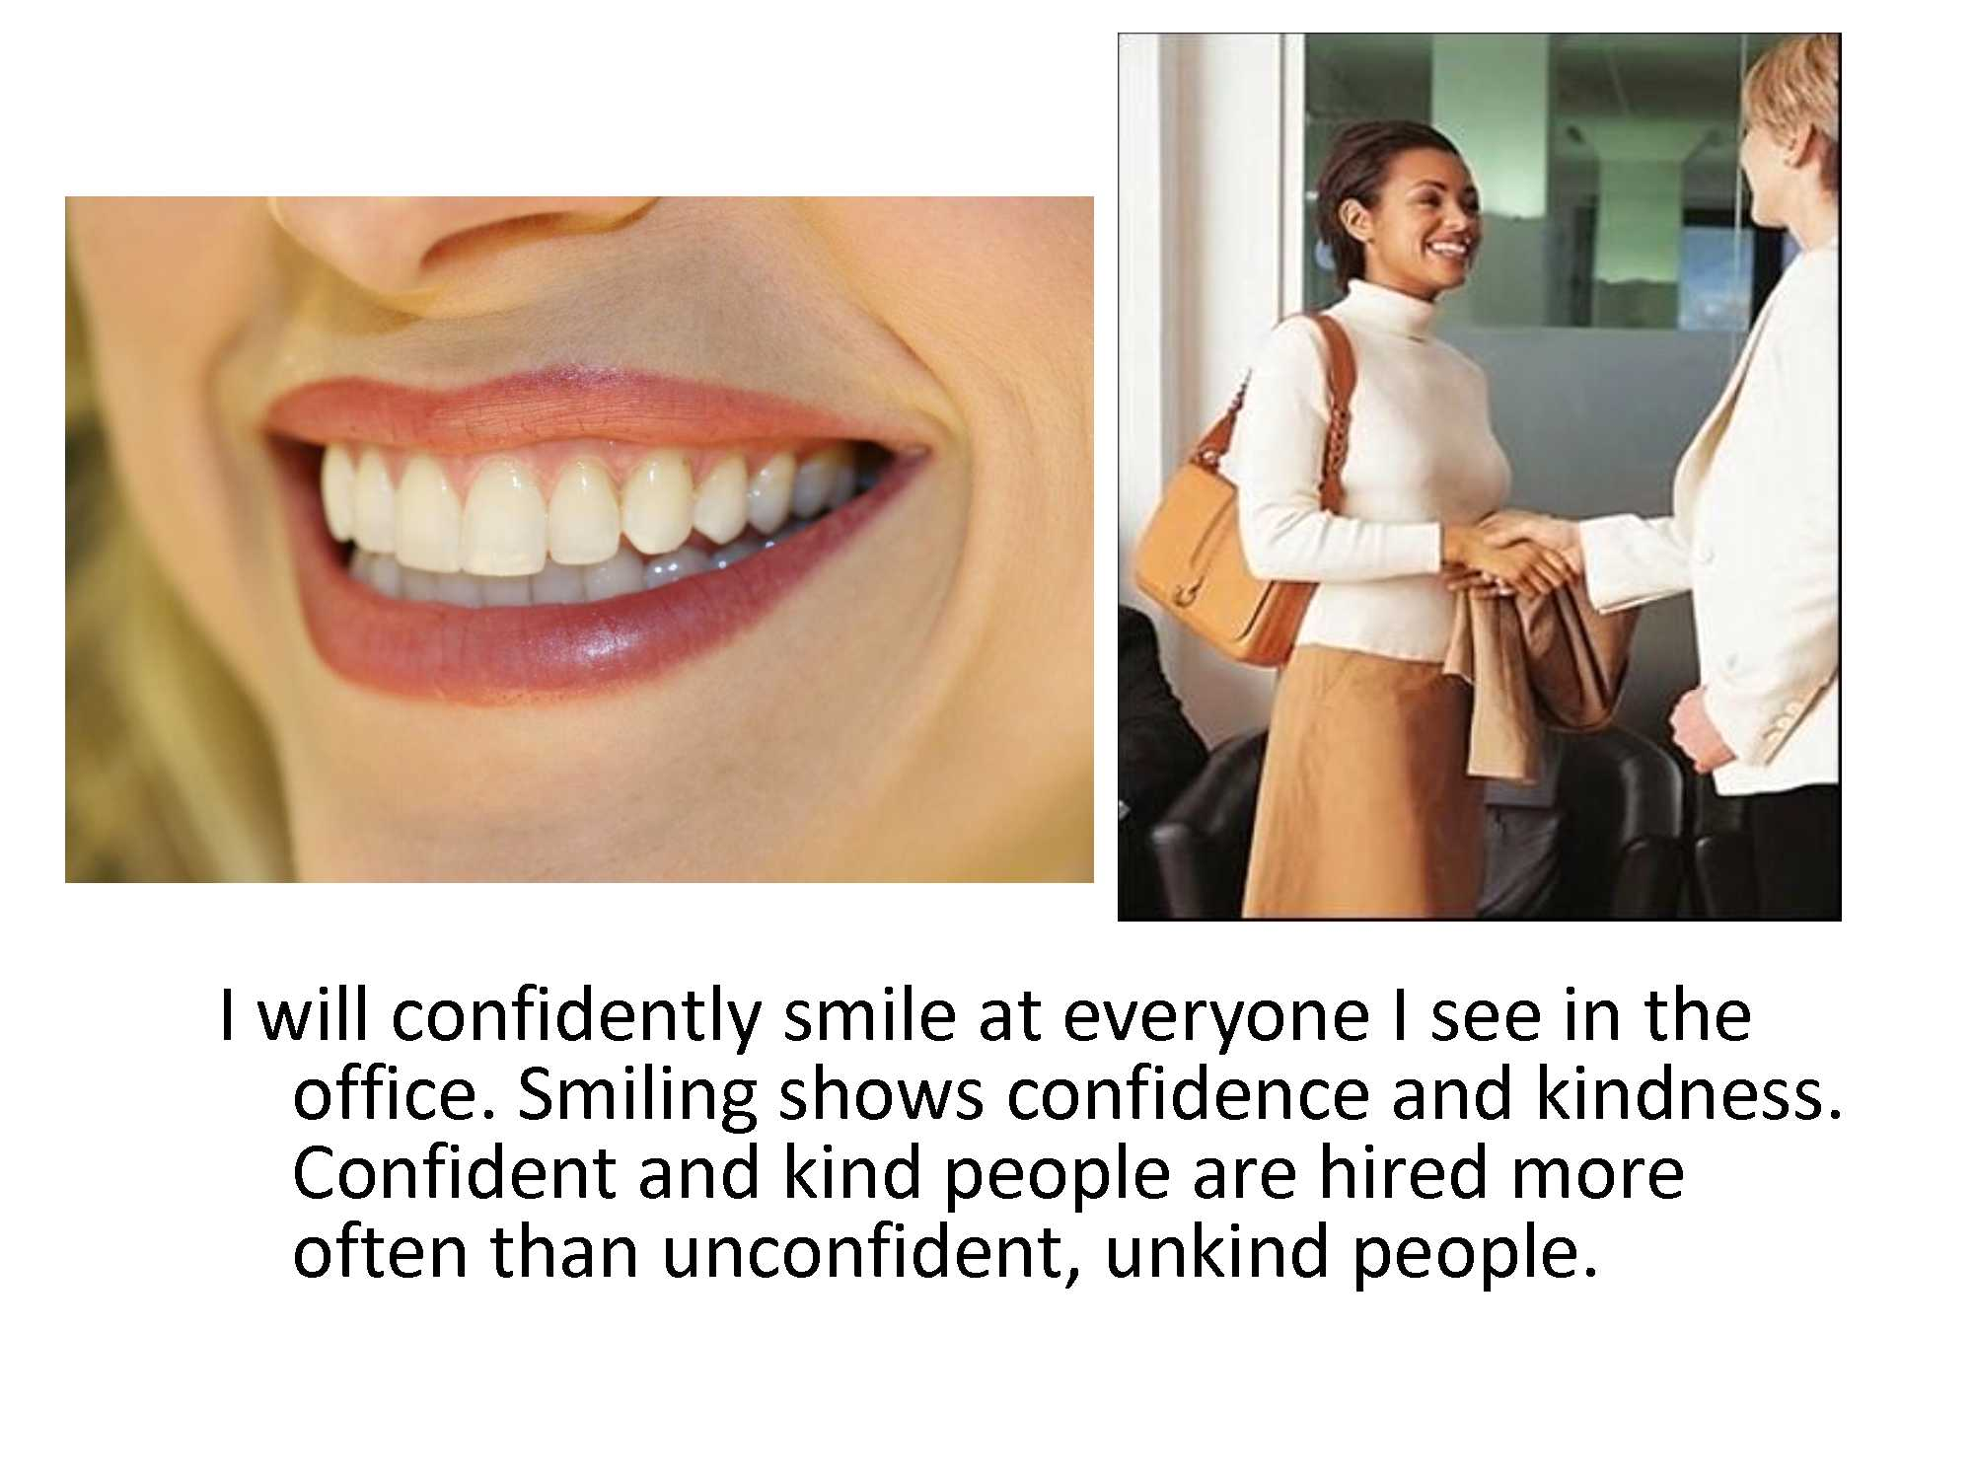
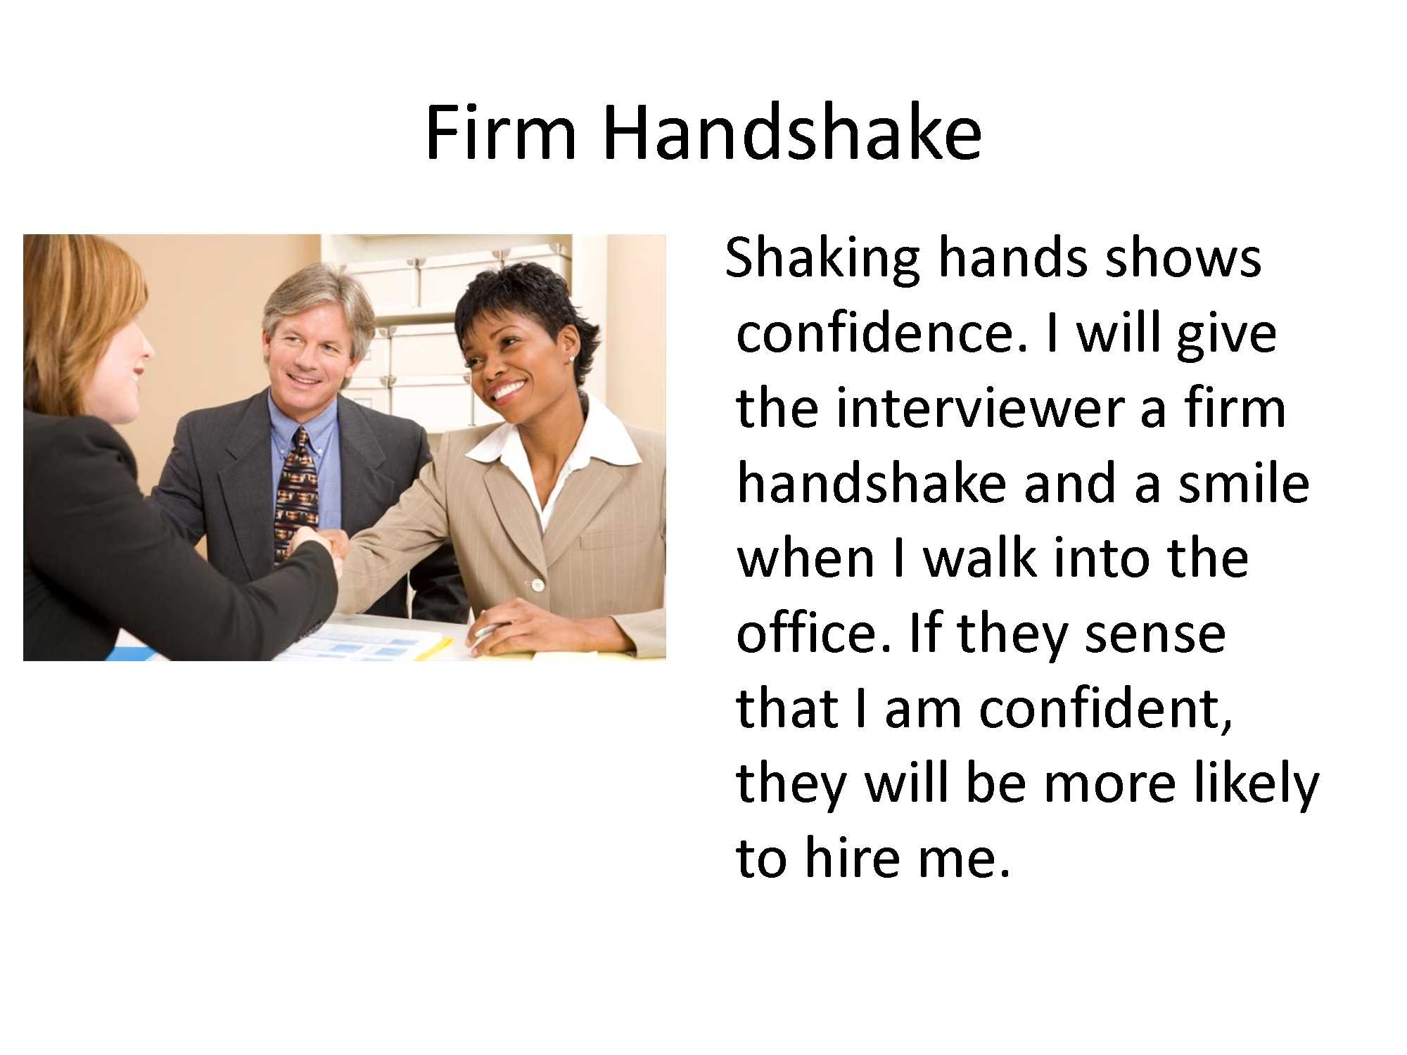
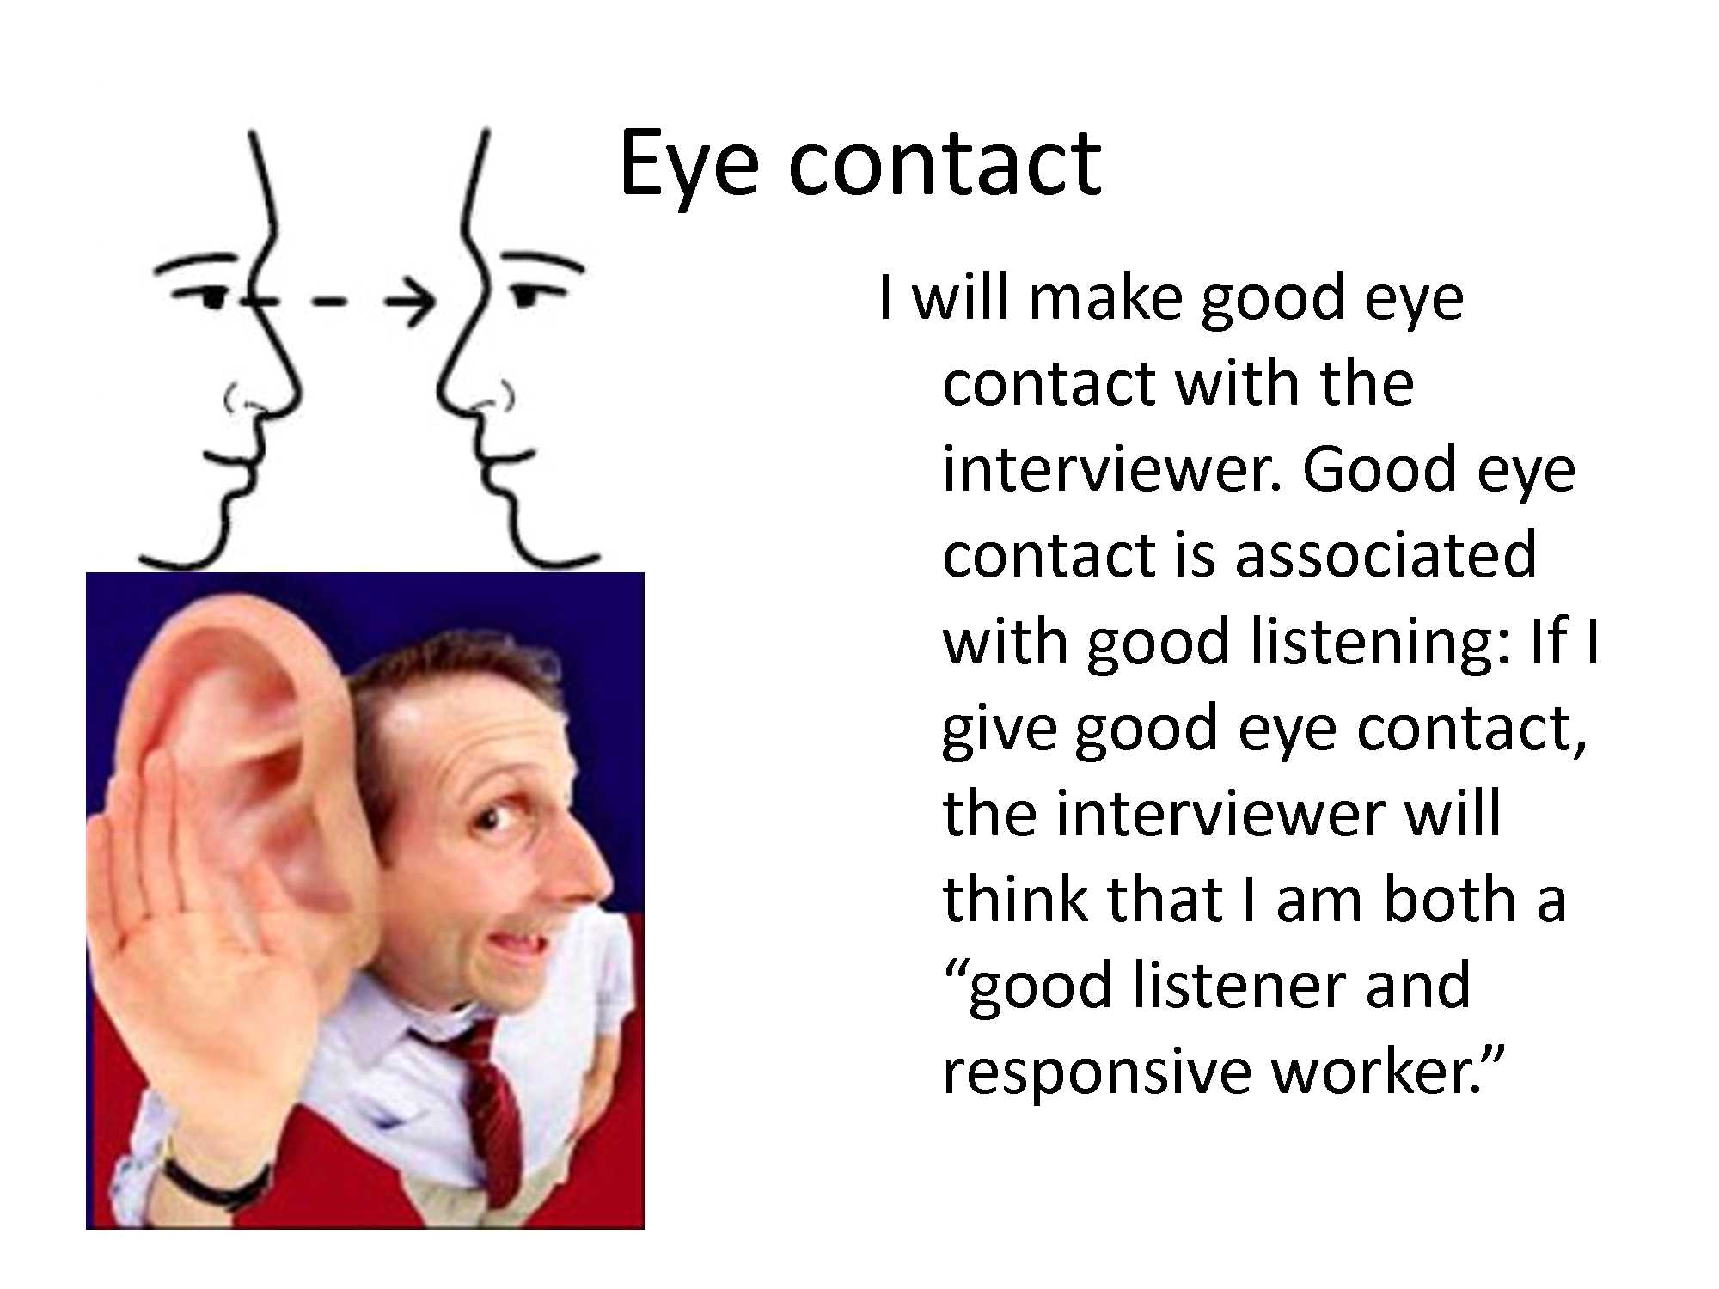
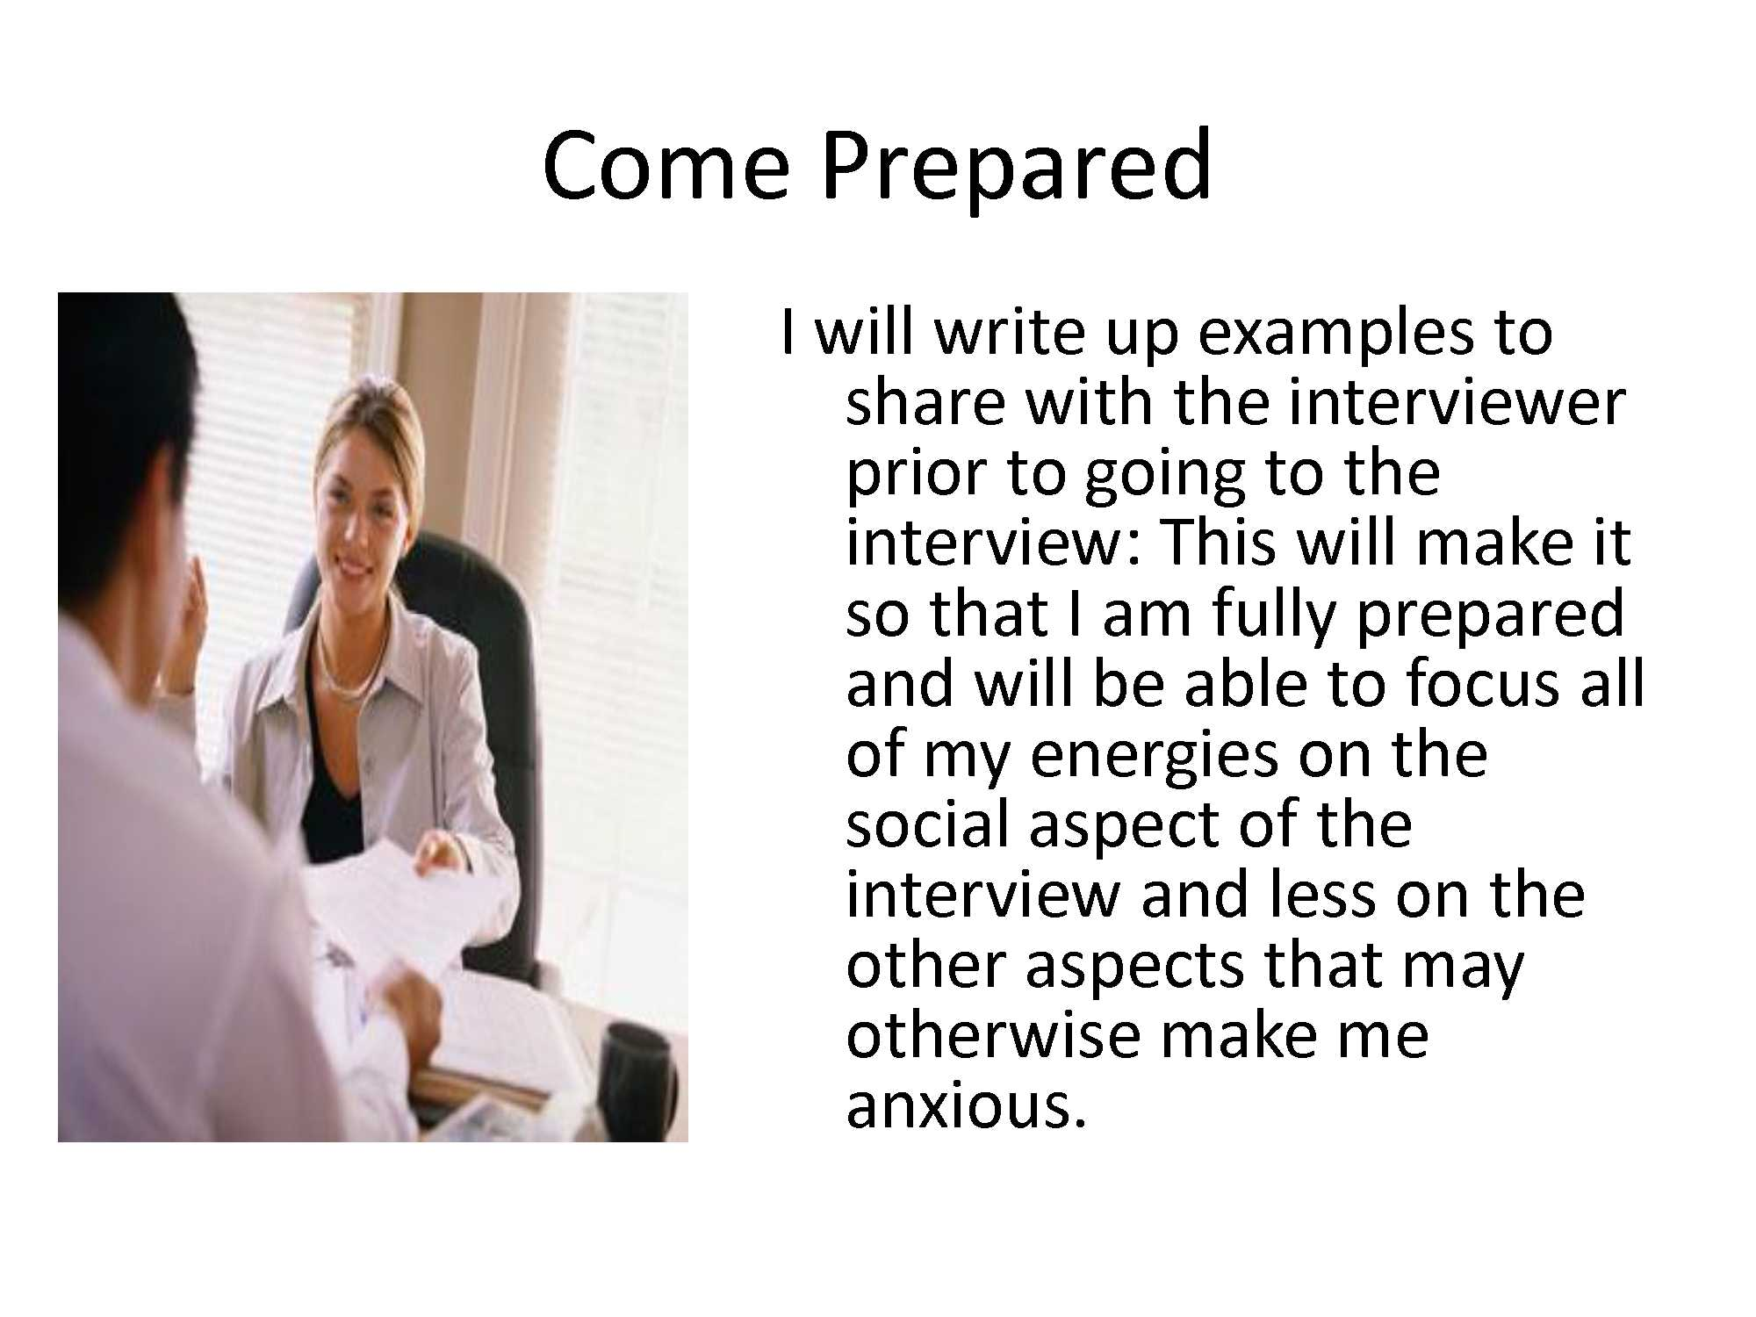
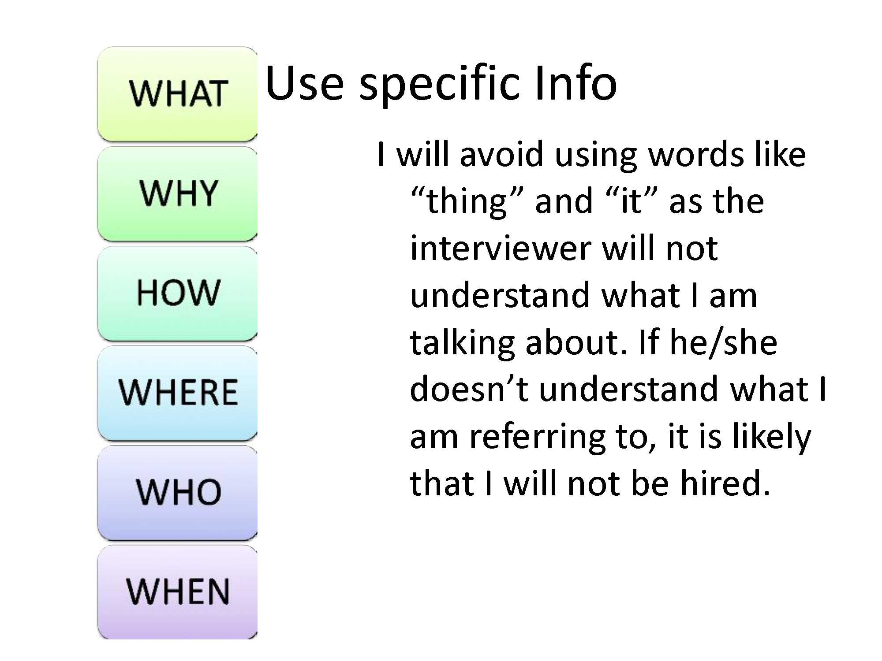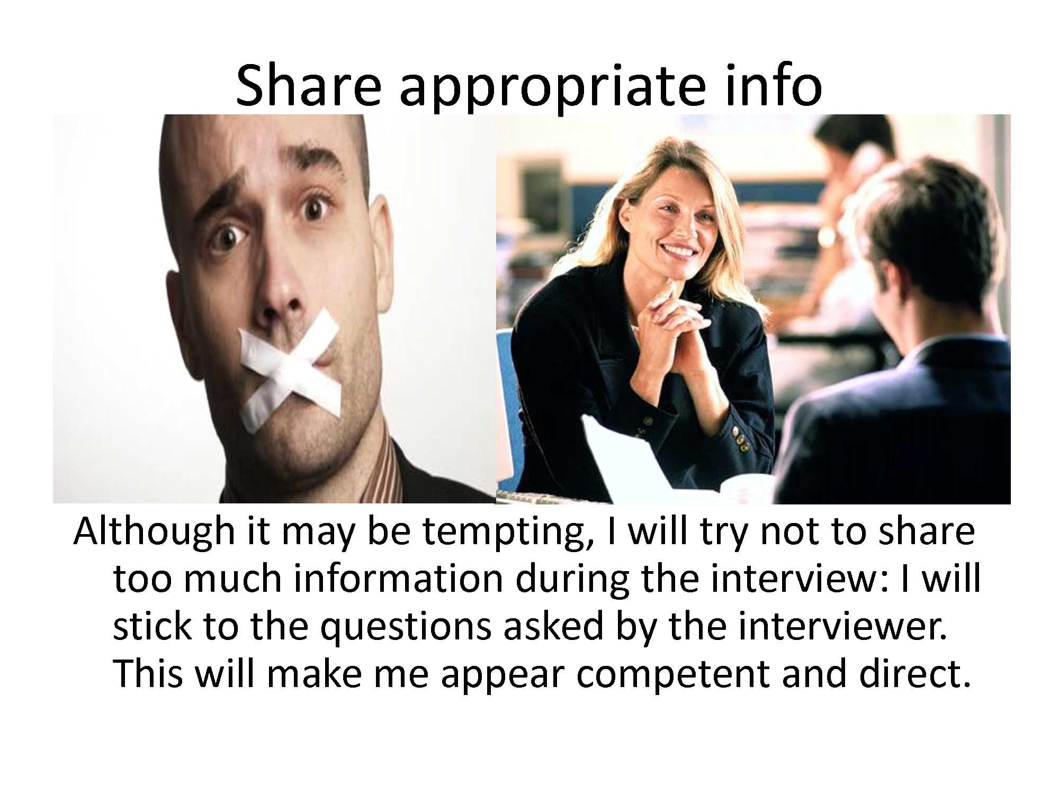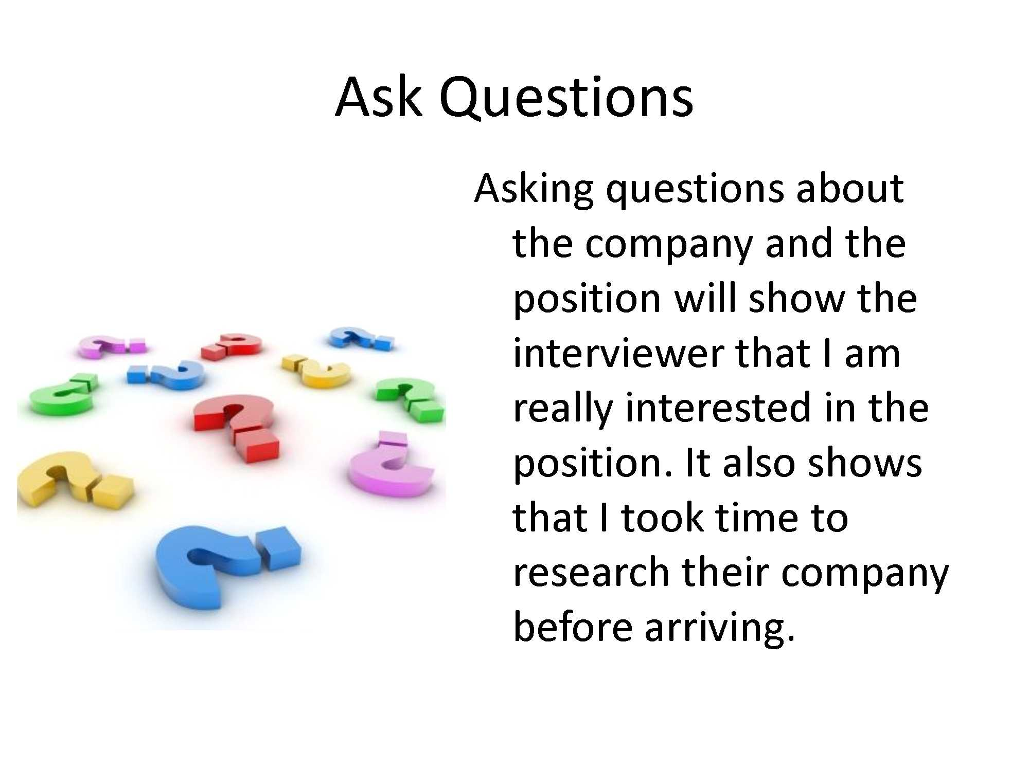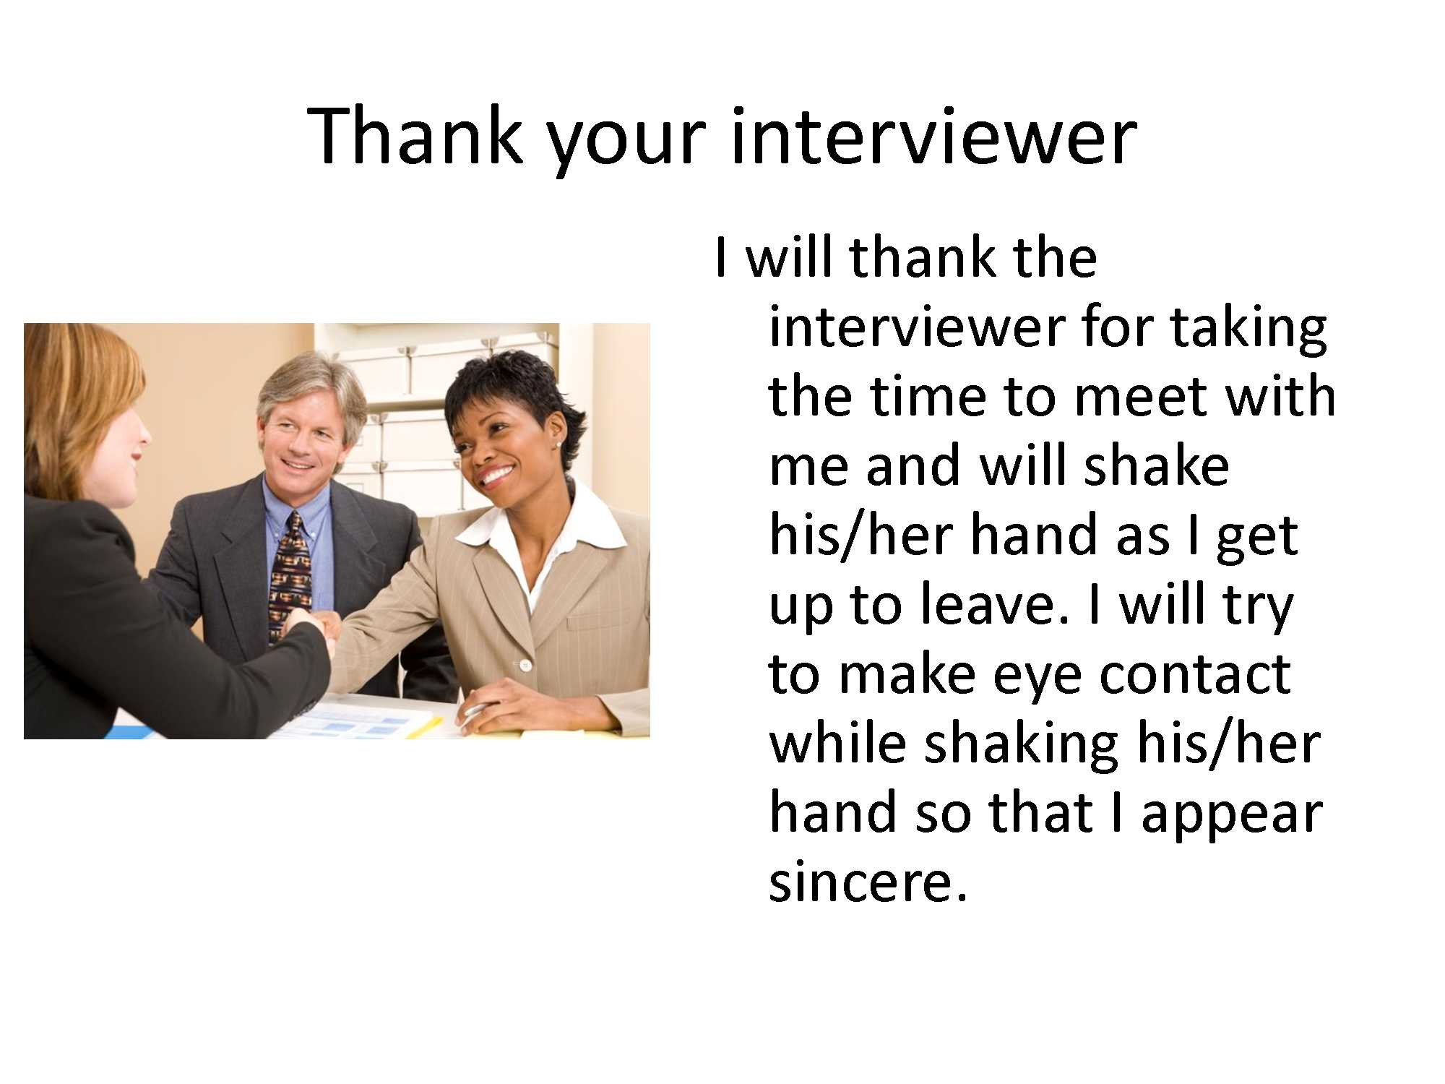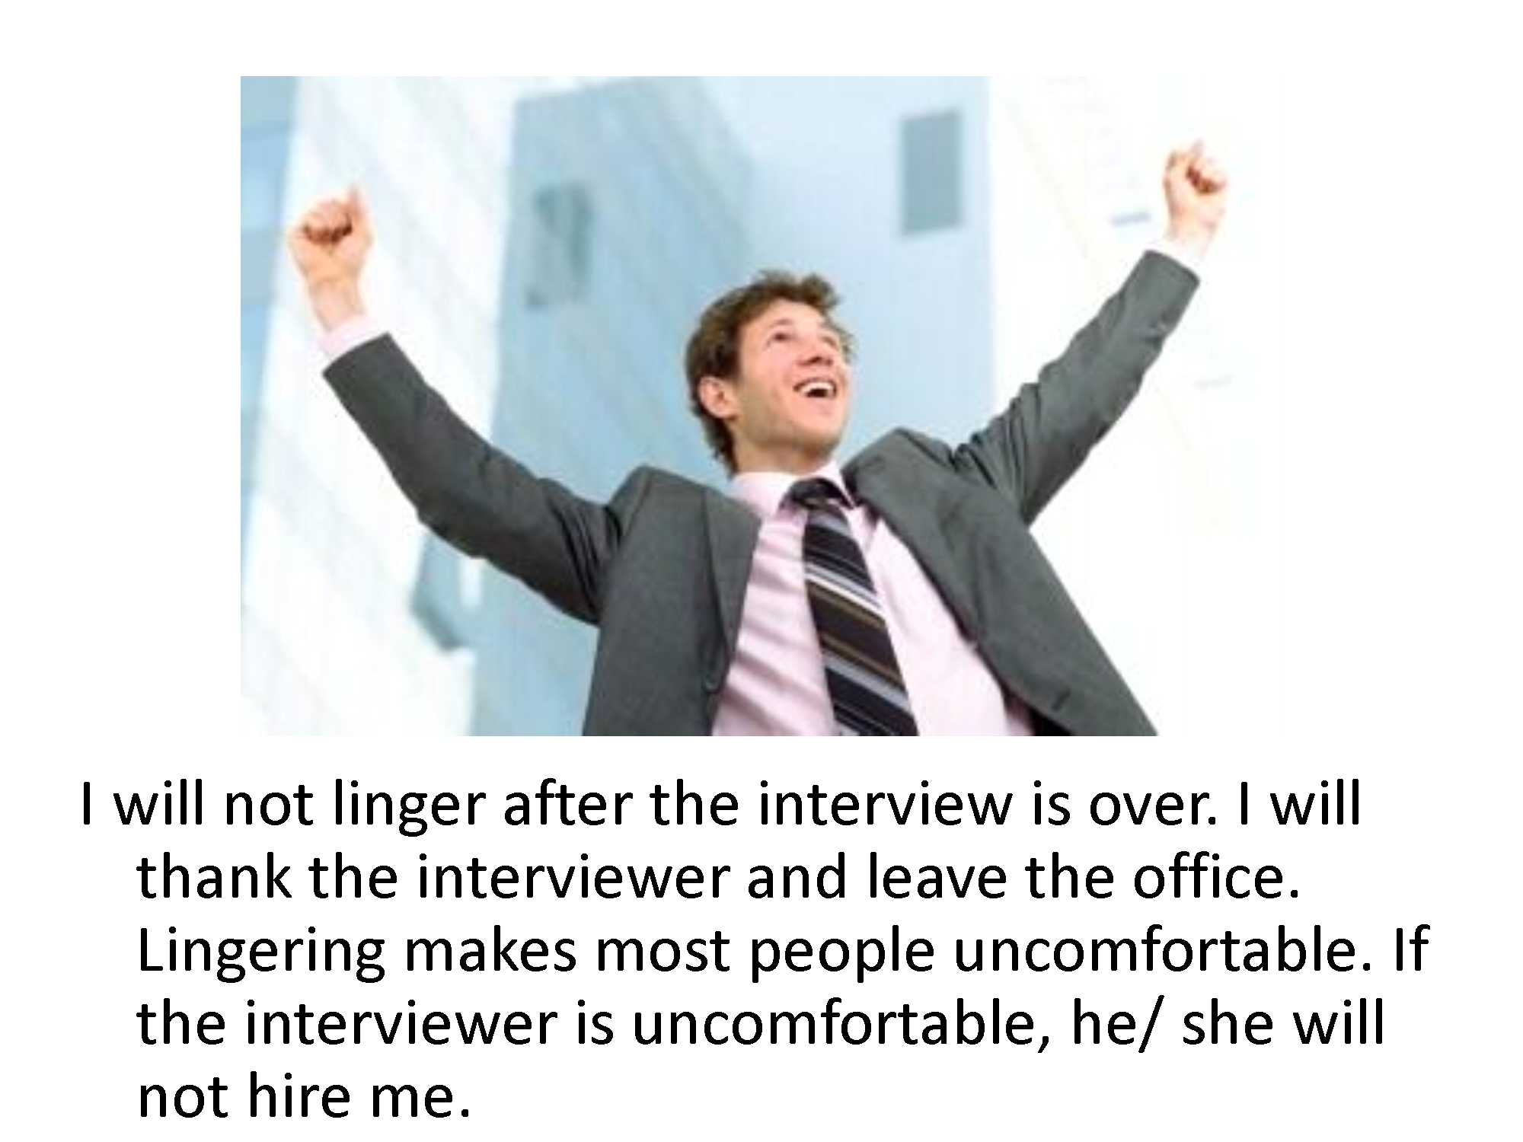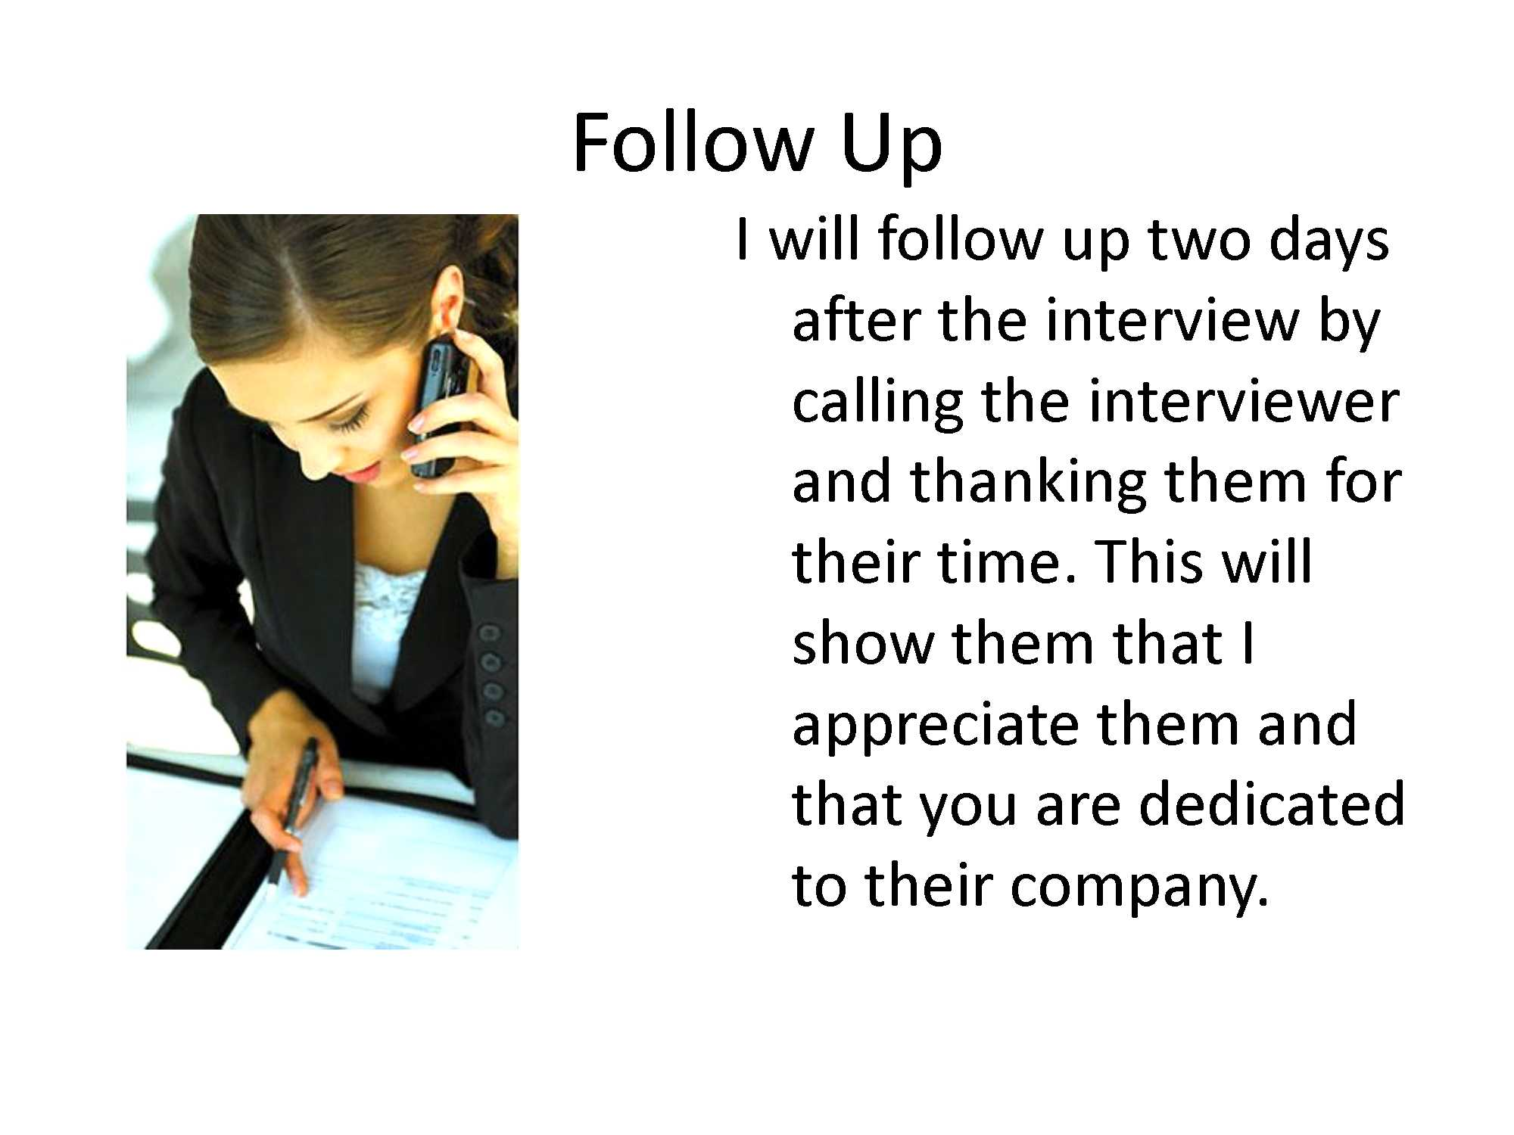

Social Story – Job Interview
https://youtu.be/Cnk_4wTdTXQ

Interview Role Playing Activities and Examples

Role Playing Example 1 (Good interview example) – http://idahotc.com/portals/29/docs/idvr/dvr/6a.pdf
Role Playing Example 2 (Poor interview example) - http://www.idahotc.com/Portals/29/Docs/IDVR/DVR/6b.pdf
Preparing for a Successful Job Interview - http://www.fldoe.org/core/fileparse.php/7531/urlt/successful-job-interview.pdf

Job Interview Videos
IT Interview Gone Wrong – A humorous clip to show older students what an interview should not and should look like.
https://www.youtube.com/watch?v=ogSJV2IOZ6o&index=21&list=PL2EDpZLFeQSy9mML_1sTnkrwLFvLjym_V
5 Mistakes to Avoid for Job Interviews
https://www.youtube.com/watch?v=ogSJV2IOZ6o&index=21&list=PL2EDpZLFeQSy9mML_1sTnkrwLFvLjym_V
No Work Experience? – How to answer the question “Tell me about yourself”
https://www.youtube.com/watch?v=z40_xz20h5w
Snagajob Youtube Channel - Great resource for informative videos on job searching and interviews
https://www.youtube.com/user/snagajob/featured

Informational Interviews vs. Job Interviews
Background: Workforce 2020 is a great platform in which students are allowed to either learn more about an employer through an informational interview or to participate in a mock interview with different employers. It is important for students to communicate their needs to the person with which they are interviewing.
Preparing for an Informational Interview

